**MESD LMS Documentation – Create/edit/delete Quiz for her/his classes**

**Purpose**

To facilitate with creating/editing/deleting quizzes for her/his classes.

**Background**

This module handles requests directly from Senior Educator’swithin the Moodle system, allowing a Senior Educator to create/edit/delete quizzes for her/him.

**Usage**

**Creating quizzes**

1. Login as a Senior Educator.
2. Go to *‘My courses’* then select the course where you want add the quiz.
3. Toggle on *‘Edit mode’* on the top right corner of the screen*.*

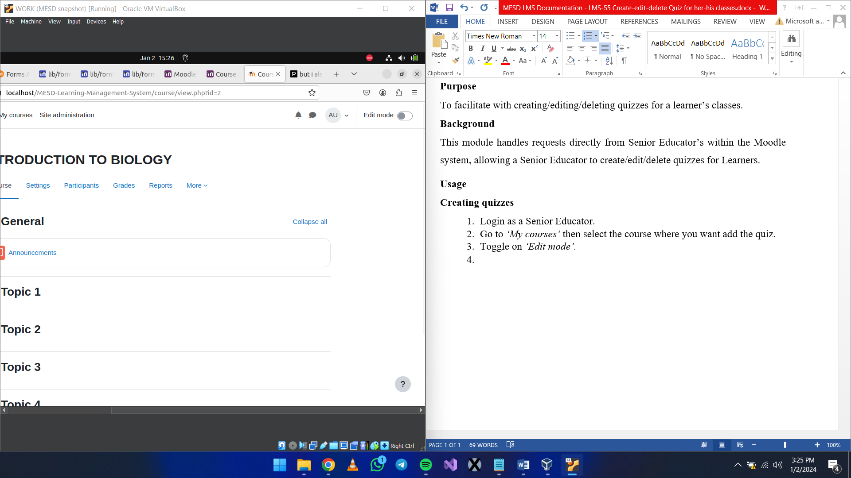

1. Click on *‘Add an activity or resource’* then select *‘Quiz’*.

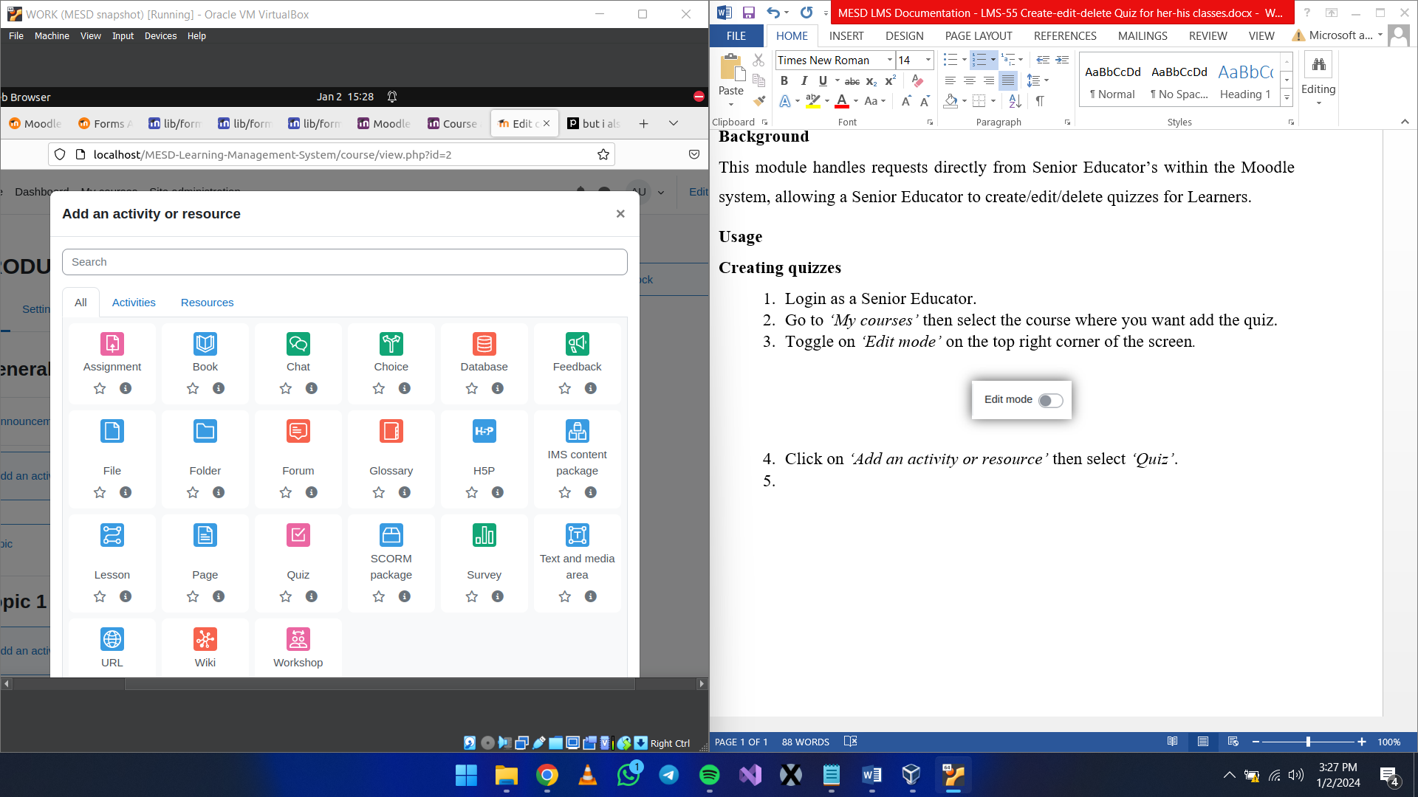

1. Enter the details like the quiz name, description, etc., and click *‘Save and display’*. Open the newly created quiz then click on *‘Add question’* to add questions to the quiz.

**Editing quizzes**

1. Select the quiz. This will take you to the quiz editing screen. Here, you can add new questions, edit existing questions, or delete questions.

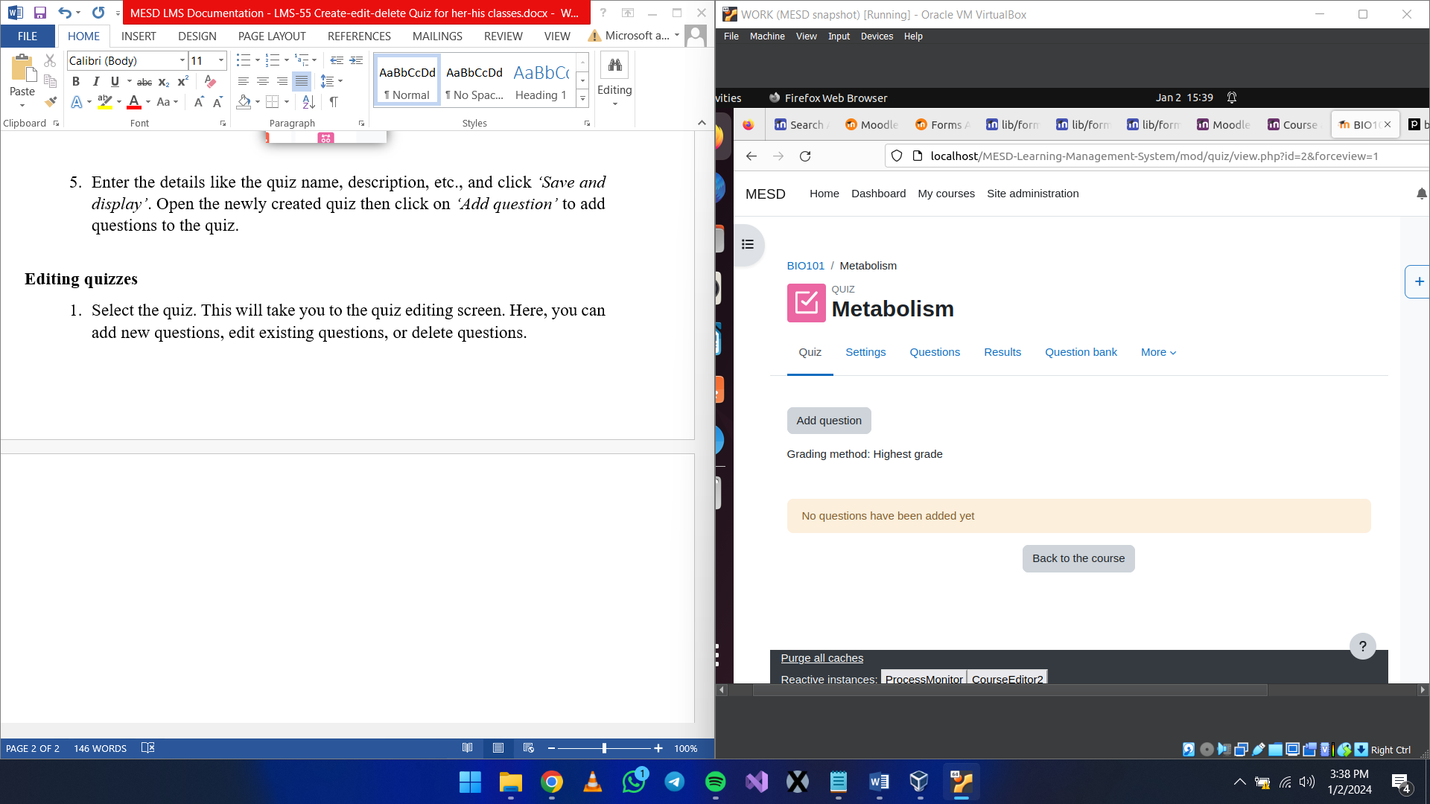

1. Quiz
   1. Allows you to add new questions to the quiz. Click on the *‘Add question’* button to add a new question.
   2. Select the *‘Add’* button to add a new question.

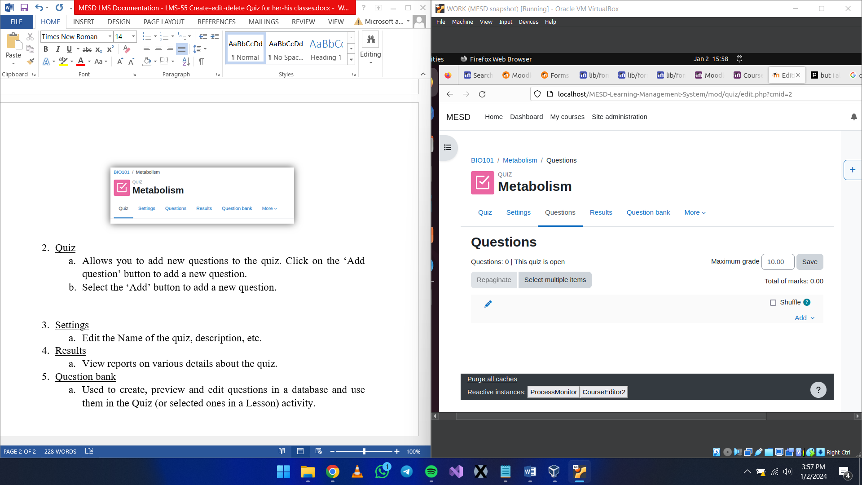

* 1. Click on *‘a new question’* to add a new type of question.
  2. Select the type of question then click on *‘Add’*.

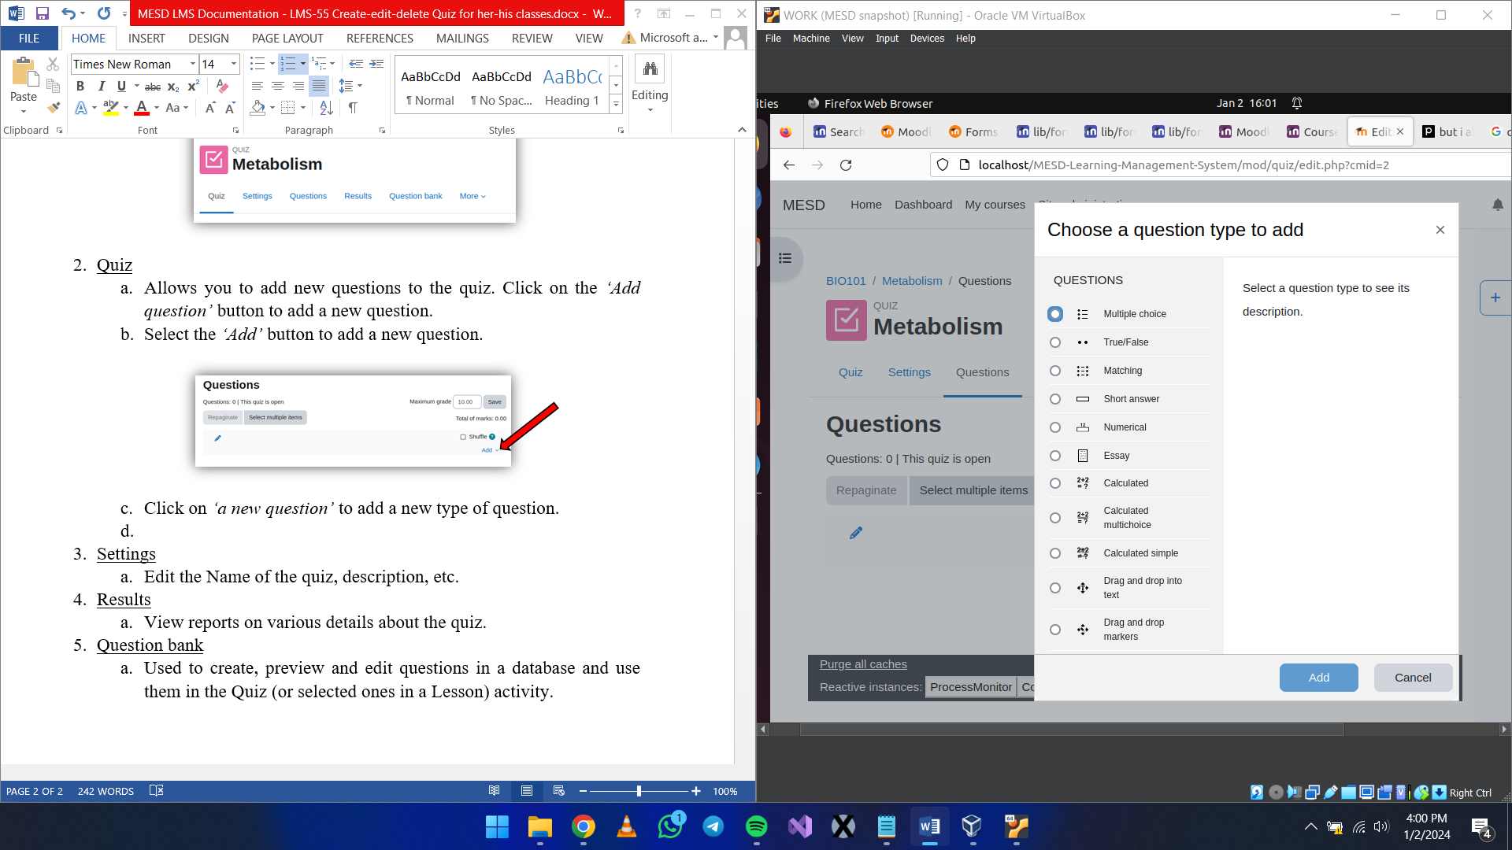

* 1. Edit the question details the click on *‘Save changes’*.

1. Settings
   1. Edit the Name of the quiz, description, etc.
2. Results
   1. View reports on various details about the quiz.
3. Question bank
   1. Used to create, preview and edit questions in a database and use them in the Quiz (or selected ones in a Lesson) activity.

**Deleting quizzes**

1. Click on the *‘Edit mode’* toggle.
2. Go to the course where you want to delete the quiz.
3. Click on the three dots on the quiz you want to view its options, select *‘Delete’*.

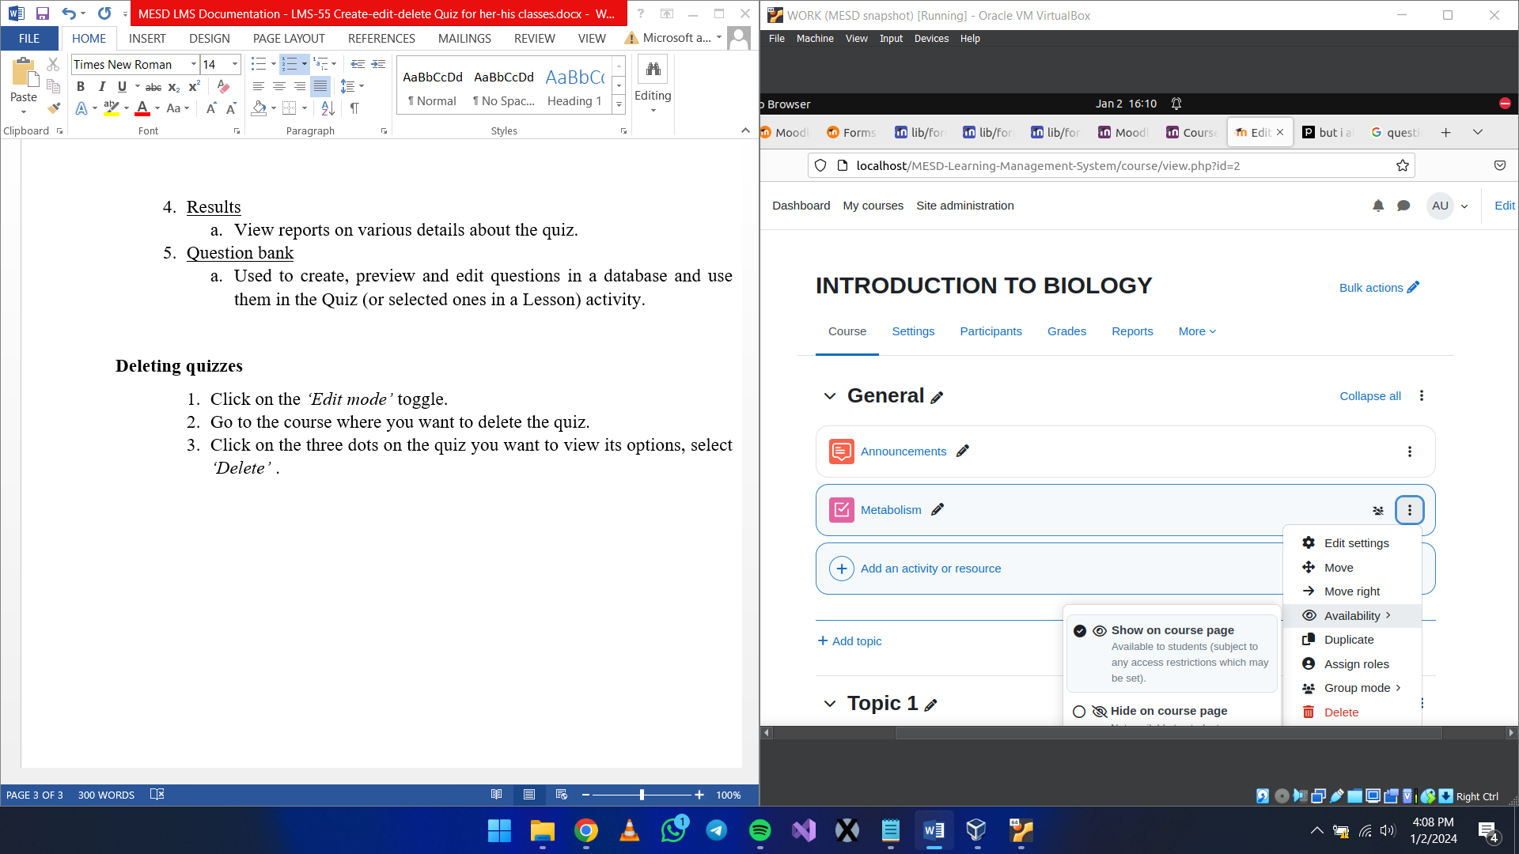

1. When the prompt appears click *‘Delete’.*